Your Name
Work About Contact
Get in touch ☰

Hi, I'm Josef — motion & 3D artist
I create motion graphics, product renders and packaging visuals. I focus on photoreal materials, clean lighting and storytelling. Scroll to see selected projects.
See projects

Featured
Juliet — packaging concept / 3D render
Read my Résumé Contact

Selected Projects


Juliet — Packaging
3D render / Product visuals


Graded Card Case
Concept / Visual


The Mighty — Slow Feeder
Product render

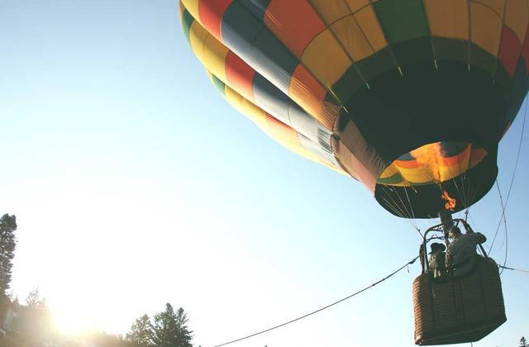
Neck Head Harness
Prototype render

About
I’m a motion designer and 3D generalist. I combine technical knowledge of materials & lighting with storytelling to produce product visuals and short animations used in branding and presentations.

Skills
- Blender / Cinema4D
- Octane / Redshift
- After Effects / Premiere
- Photoshop / Illustrator

Selected clients
Brand A • Brand B • Studio C

Contact
Interested in working together? Drop a note.
Send message Or email me
© " + new Date().getFullYear() + " Your Name • Built with ❤️

